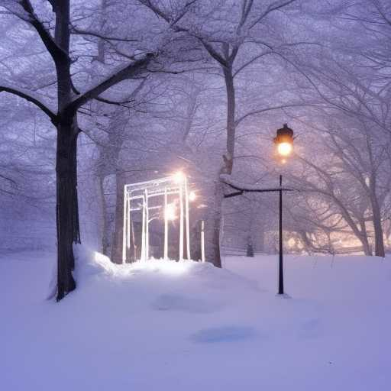
GALAXIES OF FIRE & SNOW

Fires and snows
Swirling galaxies of love
A silent stillness
Reassuring lampposts beam into the night
Angels alight
Salvation like a new star, born within an Interior Castle
Sorrow dug a deep well in my soul
Blessed are those who mourn
For their cisterns will be full of joy

